What if we call run() method directly instead start() method?

|  |
| --- |
| * Each thread starts in a separate call stack. * Invoking the run() method from main thread, the run() method goes onto the current call   stack rather than at the beginning of a new call stack. |

1. **class** TestCallRun1 **extends** Thread{
2. **public** **void** run(){
3. System.out.println("running...");
4. }
5. **public** **static** **void** main(String args[]){
6. TestCallRun1 t1=**new** TestCallRun1();
7. t1.run();//fine, but does not start a separate call stack
8. }
9. }

[**Test it Now**](http://www.javatpoint.com/opr/test.jsp?filename=TestCallRun1)

Output:running...

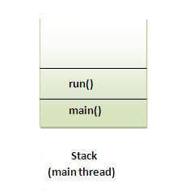 ***Problem if you direct call run() method***

1. **class** TestCallRun2 **extends** Thread{
2. **public** **void** run(){
3. **for**(**int** i=1;i<5;i++){
4. **try**{Thread.sleep(500);}**catch**(InterruptedException e){System.out.println(e);}
5. System.out.println(i);
6. }
7. }
8. **public** **static** **void** main(String args[]){
9. TestCallRun2 t1=**new** TestCallRun2();
10. TestCallRun2 t2=**new** TestCallRun2();
12. t1.run();
13. t2.run();
14. }
15. }

[**Test it Now**](http://www.javatpoint.com/opr/test.jsp?filename=TestCallRun2)

Output:1

2

3

4

5

1

2

3

4

5

|  |
| --- |
| As you can see in the above program that there is no context-switching because here t1 and t2 will be  treated as normal object not thread object. |